**NMAM INSTITUTE OF TECHNOLOGY**

(An Autonomous Institution affiliated to VTU, Belagavi)

Nitte – 574110, Karkala, Udupi District, Karnataka, India.



PROJECT REPORT

ON

**COMPILER DESIGN**

**SUBMITTED BY:**

**LOYD TELLIS KIRAN KUMAR A N**

4NM14CS079 4NM14CS072

V SEM, ‘B’ SEC V SEM, ‘B’ SEC

Department of CSE Department of CSE

NMAMIT, Nitte NMAMIT, Nitte

**SUBMITTED TO:**

**Mrs. JYOTHI SHETTY**

Department of Computer Science and Engineering

**SIGNATURE:**

**______________________ _____________________**

**______________________ (HOD OF CSE DEPT.)**

**NMAM INSTITUTE OF TECHNOLOGY**

**(An autonomous Institute affiliated to VTU, Belgaum)**

**Nitte-574110, Karkala, Udupi District**

**Department of Computer Science and Engineering**

**CERTIFICATE**

Certified that the project work carried out by LOYD TELLIS, USN 4nm14cs079 and KIRAN KUMAR A N, USN 4nm14cs072 , bonafide students of NMAM Institute of Technology, Nitte in fulfilment for the compiler design lab in Computer Science and Engineering during the academic year 2016– 2017.

Signature of lecturer :

Date:

**ACKNOWLEDGEMENT**

The satisfaction and euphoria that accompany the successful completion of any task would be incomplete without the mention of people who made it possible because

“Success is the abstract of hard work and perseverance, but steadfast of all is encouraging guidance.” So I acknowledge all those whose guidance and encouragement served as a beacon light and crowned my efforts with success.

I would like to thank our principal **Prof. Niranjan N. Chiplunkar** firstly, for providing us with this unique opportunity to do the project in the 5th semester of Computer Science and engineering.

I would like to thank my college administration for providing a conductive environment and also suitable facilities for this project. I would like to thank our HOD **Prof. Uday Kumar Reddy** for showing me the path and providing the inspiration required for taking theproject to its completion. It is my great pleasure to thank my guide **Mrs. Jyothi Shetty** for her continuous encouragement, guidance and support throughout this project.

I thank all the staff members of the department of CSE for providing resources for the completion of the project.

Finally I thank all those who have contributed directly or indirectly in making this project a Grand Success.

**LOYD TELLIS (4NM14CS079)**

**KIRAN KUMAR A N (4NM14CS072)**

**CONTENTS**

* **INTRODUCTION**
* **LEXICAL ANALYSIS**
* **SYNTAX ANALYSIS**
* **CONTEXT FREE GRAMMAR**
* **PARSE TREE**
* **TYPES OF PARSING**
* **PARSING TABLE**
* **SYNTAX ERROR CONDITION**
* **CONCLUSION**
* **BIBLIOGRAPHY**

**INTRODUCTION**

What is a compiler?

In order to reduce the complexity of designing and building computers, nearly all of these are made to execute relatively simple commands (but do so very quickly). A program for a computer must be built by combining these very simple commands into a program in what is called machine language. Since this is a tedious and error prone process most programming is, instead, done using a high-level programming language. This language can be very different from the machine language that the computer can execute, so some means of bridging the gap is required.

This is where the compiler comes in. A compiler translates (or compiles) a program written in a high-level programming language that is suitable for human programmers into the low-level machine language that is required by computers. During this process, the compiler will also attempt to spot and report obvious programmer mistakes. Using a high-level language for programming has a large impact on how fast programs can be developed.

The main reasons for this are:

* Compared to machine language, the notation used by programming languages is closer to the way humans think about problems.
* The compiler can spot some obvious programming mistakes.
* Programs written in a high-level language tend to be shorter than equivalent programs written in machine language.
* Another advantage of using a high-level level language is that the same program can be compiled to many different machine languages and, hence, be brought to run on many different machines.
* On the other hand, programs that are written in a high-level language and automatically translated to machine language may run somewhat slower than programs that are hand-coded in machine language. Hence, some time-critical programs are still written partly in machine language.
* A good compiler will, however, be able to get very close to the speed of hand-written machine code when translating well-structured programs.

**THE PHASES OF A COMPILER**

The compilation process is a sequence of various phases. Each phase takes input from its previous stage, has its own representation of source program, and feeds its output to the next phase of the compiler. Let us understand the phases of a compiler.



**Lexical Analysis**

The first phase of scanner works as a text scanner. This phase scans the source code as a stream of characters and converts it into meaningful lexemes. Lexical analyser represents these lexemes in the form of tokens as:

**<token-name, attribute-value>**

**Syntax Analysis**

The next phase is called the syntax analysis or **parsing**. It takes the token produced by lexical analysis as input and generates a parse tree (or syntax tree). In this phase, token arrangements are checked against the source code grammar, i.e., the parser checks if the expression made by the tokens is syntactically correct.

**Semantic Analysis**

Semantic analysis checks whether the parse tree constructed follows the rules of language. For example, assignment of values is between compatible data types, and adding string to an integer. Also, the semantic analyser keeps track of identifiers, their types and expressions; whether identifiers are declared before use or not, etc. The semantic analyser produces an annotated syntax tree as an output.

**Intermediate Code Generation**

After semantic analysis, the compiler generates an intermediate code of the source code for the target machine. It represents a program for some abstract machine. It is in between the high-level language and the machine language. This intermediate code should be generated in such a way that it makes it easier to be translated into the target machine code.

**Code Optimization**

The next phase does code optimization of the intermediate code. Optimization can be assumed as something that removes unnecessary code lines, and arranges the sequence of statements in order to speed up the program execution without wasting resources (CPU, memory).

**Code Generation**

In this phase, the code generator takes the optimized representation of the intermediate code and maps it to the target machine language. The code generator translates the intermediate code into a sequence of (generally) re-locatable machine code. Sequence of instructions of machine code performs the task as the intermediate code would do.

**Symbol Table**

It is a data-structure maintained throughout all the phases of a compiler. All the identifiers’ names along with their types are stored here. The symbol table makes it easier for the compiler to quickly search the identifier record and retrieve it. The symbol table is also used for scope management.

**LEXICAL ANALYSIS**

Lexical analysis is the first phase of a compiler. It takes the modified source code from language pre-processors that are written in the form of sentences. The lexical analyser breaks these syntaxes into a series of tokens, by removing any whitespace or comments in the source code. If the lexical analyser finds a token invalid, it generates an error. The lexical analyser works closely with the syntax analyser.

It reads character streams from the source code, checks for legal tokens, and passes the data to the syntax analyser when it demands. The main purpose of lexical analysis is to make life easier for the subsequent syntax analysis phase. In theory, the work that is done during lexical analysis can be made an integral part of syntax analysis, and in simple systems this is indeed often done. However, there are reasons for keeping the phases separate:

* Efficiency: A lexer may do the simple parts of the work faster than the more general parser can. Furthermore, the size of a system that is split in two may be smaller than a combined system. This may seem paradoxical but, as we shall see, there is a non-linear factor involved which may make a separated system smaller than a combined system.
* Modularity: The syntactical description of the language need not be cluttered with small lexical details such as white-space and comments.
* Tradition: Languages are often designed with separate lexical and syntactical phases in mind, and the standard documents of such languages typically separate lexical and syntactical elements of the languages.

**Token:**  Token is a sequence of characters that can be treated as a single logical entity. Typical tokens are,

1) Identifiers

2) Keywords

3) Operators

4) Special symbols

5) Constants

**Pattern:** A set of strings in the input for which the same token is produced as output. This set of strings is described by a rule called a pattern associated with the token.

**Lexeme:** A lexeme is a sequence of characters in the source program that is matched by the pattern for a token.

## Problem statement:

## Design a c/c++ compiler for the following pseudo code

int main()

begin

int count=1;

while(n>1)

count=count+1;

n=n/2;

end while

return count

end

**Eg:** The lexical program for above problem statement is

#include<stdio.h>

#include<ctype.h>

#include<string.h>

void keyw(char *p);

int i=0,id=0,kw=0,num=0,op=0;

char keys[5][10]={"end", "main", "int", "begin", "while"};

main()

{

char ch, str[25],seps[15]=" \t\n,;(){}[]#\"<>",oper[]="!%^&*-+=~|.<>/?";

int j;

char fname[50];

FILE *f1;

printf("enter file path (drive:\\fold\\filename)\n");

scanf("%s",fname);

f1 = fopen(fname,"r");

if(f1==NULL)

{

printf("file not found");

exit(0);

}

while((ch=fgetc(f1))!=EOF)

{

for(j=0;j<=14;j++)

{

if(ch==oper[j])

{

printf("%c is an operator\n",ch);

op++;

str[i]='\0';

keyw(str);

}

}

for(j=0;j<=14;j++)

{

if(i==-1)

break;

if(ch==seps[j])

{

str[i]='\0';

keyw(str);

}

}

if(i!=-1)

{

str[i]=ch;

i++;

}

else

i=0;

}

printf("Keywords: %d\nIdentifiers: %d\nOperators: %d\nNumbers: %d\n",kw,id,op,num); //getch();

}

void keyw(char *p)

{

int k,flag=0;

for(k=0;k<=4;k++)

{

if(strcmp(keys[k],p)==0)

{

printf("%s is a keyword\n",p);

kw++;

flag=1;

break;

}

}

if(flag==0)

{

if(isdigit(p[0]))

{

printf("%s is a number\n",p);

num++;

}

else

{

//if(p[0]!=13&&p[0]!=10)

if(p[0]!='\0')

{

printf("%s is an identifier\n",p);

id++;

}

}

}

i=-1;

}

**Explanation for the above code**

In the code above, an array of keywords that are used in the program have been declared.

When a statement of the program is given as input to the program, the strtok function divides the input with space, semicolon and comma as delimiter and assigns it to a variable named token every time in the loop.

Every time the token is compared with each keyword in the array and if it matches any of them, then it is displayed as a keyword.

If it matches with any of the operators, then it’s an operator.

If it matches with numbers, then it’s a number.

Else it is an identifier

**Output:**

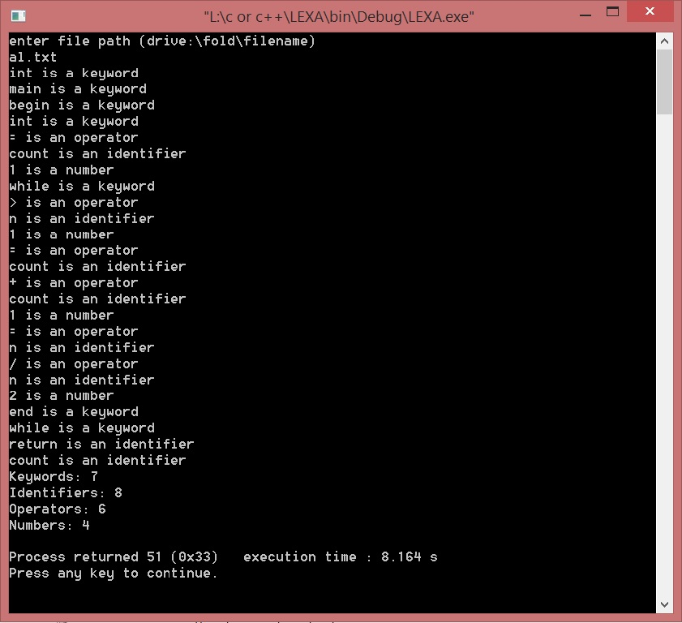

**TRANSITION DIAGRAM:**

* **Keywords**

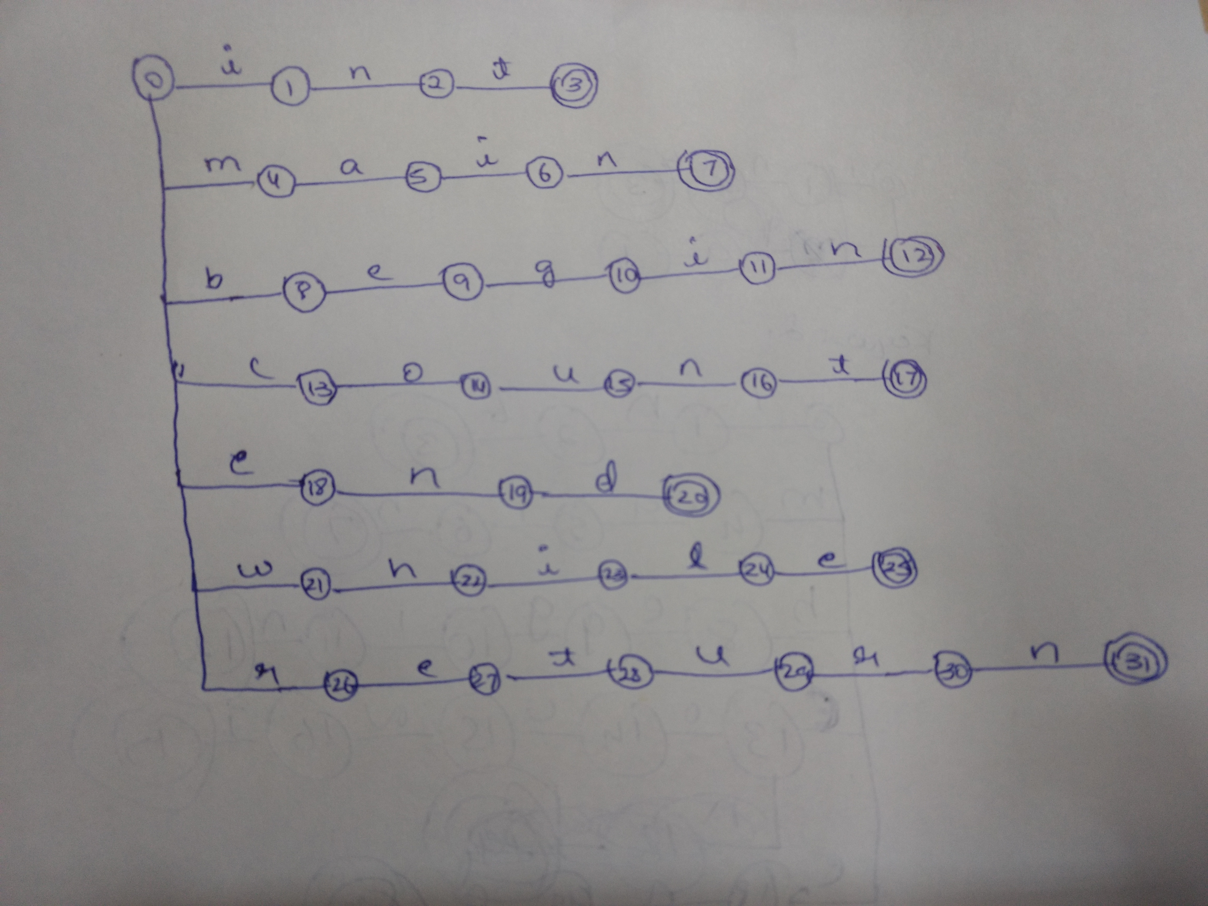

* **Operators**

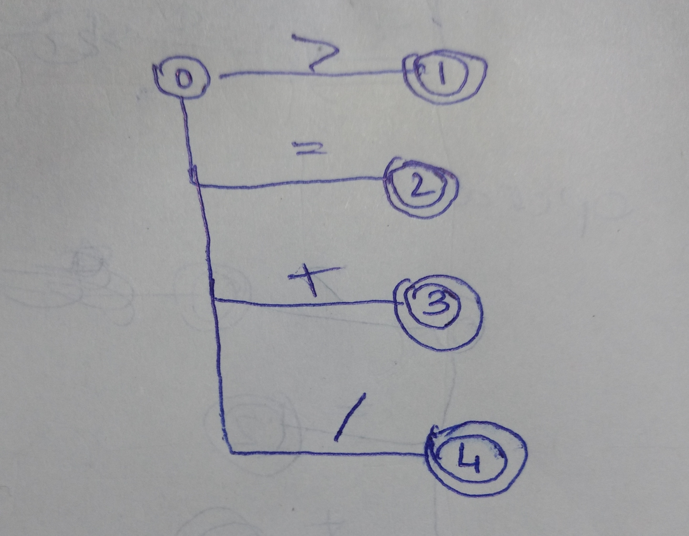

**SYNTAX ANALYSIS**

Syntax analysis or parsing is the second phase of a compiler. In this chapter, we shall learn the basic concepts used in the construction of a parser.

[**Role of the Parser**](http://compilerdesigndetails.blogspot.com/2012/02/role-of-parser.html)

·         In the compiler model, the parser obtains a string of tokens from the lexical analyser, and verifies that the string can be generated by the grammar for the source language.

·         The parser returns any syntax error for the source language.

**[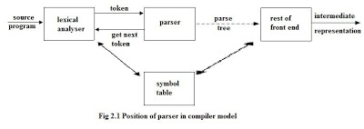](http://1.bp.blogspot.com/-rQj15mJzm2I/TzOMd_8xSfI/AAAAAAAAAF4/h60sPn1m9Og/s1600/aas.jpg)**

**•**There are three general types’ parsers for grammars.

·         Universal parsing methods such as the Cocke-Younger-Kasami algorithm and Earley’s algorithm can parse any grammar. These methods are too inefficient to use in production compilers.

·         The methods commonly used in compilers are classified as either top-down parsing or bottom-up parsing.

·         Top-down parsers build parse trees from the top (root) to the bottom (leaves).

·         Bottom-up parsers build parse trees from the leaves and work up to the root.

·         In both case input to the parser is scanned from left to right, one symbol at a time.

**•**The output of the parser is some representation of the parse tree for the stream of tokens

·         There are number of tasks that might be conducted during parsing. Such as;

o   Collecting information about various tokens into the symbol table.

o   Performing type checking and other kinds of semantic analysis.

o   Generating intermediate code.

·        Syntax Error Handling:

o   Planning the error handling right from the start can both simplify the structure of a compiler and improve its response to errors.

o   The program can contain errors at many different levels. e.g.,

§  Lexical – such as misspelling an identifier, keyword, or operator.

§  Syntax – such as an arithmetic expression with unbalanced parenthesis.

§  Semantic – such as an operator applied to an incompatible operand.

§  Logical– such as an infinitely recursive call.

·         Much of the error detection and recovery in a compiler is centred on the syntax analysis phase.

o   One reason for this is that many errors are syntactic in nature or are exposed when the stream of tokens coming from the lexical analyser disobeys the grammatical rules defining the programming language.

o   Another is the precision of modern parsing methods; they can detect the presence of syntactic errors in programs very efficiently.

·         The error handler in a parser has simple goals:

o   It should the presence of errors clearly and accurately.

o   It should recover from each error quickly enough to be able to detect subsequent errors.

* It should not significantly slow down the processing of correct programs.

**Error-Recovery Strategies:**

o   There are many different general strategies that a parser can employ to recover from a syntactic error.

§  Panic mode

§  Phrase level

§  Error production

§  Global correction

**CONTEXT-FREE GRAMMAR**

In this section, we will first see the definition of context-free grammar and introduce terminologies used in parsing technology.

A context-free grammar has four components:

* A set of **non-terminals** (V). Non-terminals are syntactic variables that denote sets of strings. The non-terminals define sets of strings that help define the language generated by the grammar.
* A set of tokens, known as **terminal symbols** (Σ). Terminals are the basic symbols from which strings are formed.
* A set of **productions** (P). The productions of a grammar specify the manner in which the terminals and non-terminals can be combined to form strings. Each production consists of a **non-terminal** called the left side of the production, an arrow, and a sequence of tokens and/or **on- terminals**, called the right side of the production.
* One of the non-terminals is designated as the start symbol (S); from where the production begins.

The strings are derived from the start symbol by repeatedly replacing a non-terminal (initially the start symbol) by the right side of a production, for that non-terminal.

## Parse Tree

A parse tree is a graphical depiction of a derivation. It is convenient to see how strings are derived from the start symbol. The start symbol of the derivation becomes the root of the parse tree.

In a parse tree:

* All leaf nodes are terminals.
* All interior nodes are non-terminals.
* In-order traversal gives original input string.

A parse tree depicts associativity and precedence of operators. The deepest sub-tree is traversed first, therefore the operator in that sub-tree gets precedence over the operator which is in the parent nodes.

## Types of Parser

## Syntax analyzers follow production rules defined by means of context-free grammar. The way the production rules are implemented (derivation) divides parsing into two types : top-down parsing and bottom-up parsing.

## 

## 

**Top-down Parsing**

When the parser starts constructing the parse tree from the start symbol and then tries to transform the start symbol to the input, it is called top-down parsing.

* **Recursive descent parsing** : It is a common form of top-down parsing. It is called recursive, as it uses recursive procedures to process the input. Recursive descent parsing suffers from backtracking.
* **Backtracking** : It means, if one derivation of a production fails, the syntax analyzer restarts the process using different rules of same production. This technique may process the input string more than once to determine the right production.

**Bottom-up Parsing**

## As the name suggests, bottom-up parsing starts with the input symbols and tries to construct the parse tree up to the start symbol.

# *NOTE:THE TYPE OF PARSER WE HAVE USED IS TOP-DOWN PARSER*

## LL(1) Grammars

LL(1) GRAMMARS AND LANGUAGES. A context-free grammar G = (VT, VN, S, P) whose parsing table has no multiple entries is said to be *LL*(1). In the name *LL*(1),

* the first *L* stands for scanning the input from **l**eft to right,
* the second *L* stands for producing a **l**eftmost derivation,
* and the 1 stands for using **one** input symbol of look ahead at each step to make parsing action decision.

A language is said to be LL(1) if it can be generated by a LL(1) grammar. It can be shown that LL(1) grammars are

* not ambiguous and
* not left-recursive.

Eg: LL(1) grammar for above problem statement is

S --> TPES

S --> R

S -> beginSD

S ->WOCORDPWS

S ->returnPV

S -> E

T ->int

E ->MOO

E ->L

L ->VONO

M ->main

P ->_

W ->while

D ->endS

R ->VOVAOR

R -> E

C ->VON

A->ON

V ->count

V ->n

O->=

O->+

O->/

O->>

O->;

O->(

O->)

N ->1

N ->2

**First and Follow Sets**

**First :**

First(S)={int,begin,count,n,while,return, €,}

First(E)={main,count,n}

First(P)={_}

First(T)={int}

First(W)={while}

First(D)={end}

First(R)={count,n, €}

First(C)={n,count}

First(V)={count,n}

First(A)={+,/,}

First(L)={count,n}

First(O)={+,/,=,>,;,),(}

First(N)={1,2}

First(M)={main}

**Follows:**

Follow(S)={$,endS}

Follow(R)={end,$}

Follow(P)={main,count,n,while}

Follow(A)={+,/,=,>,;,(,)}

Follow(V)={+,/,=,>,;,(,)}

Follow(O)={count,n,1,2,end,$}

Follow(L)={ int,begin,count,n,while,return,$,endS }

Follow(N)={ +,/,=,>,;,(,) }

Follow(M)={ +,/,=,>,;,),(}

Follow(D)={-,endS,$}

Follow(E)={ int,begin,count,n,while,return,$,endS }

Follow(T)={_}

Follow(W)={ int,begin,count,n,while,return , +,/,=,>,;,(,),endS,$}

Follow(C)={ +,/,=,>,;,),(}

An important part of parser table construction is to create first and follow sets. These sets can provide the actual position of any terminal in the derivation. This is done to create the parsing table where the decision of replacing T[A, t] = α with some production rule.

**First Set :**

This set is created to know what terminal symbol is derived in the first position by a non-terminal. For example,

α → t β

That is, α derives t (terminal) in the very first position. So, t ∈ FIRST(α).

**Algorithm for Calculating First Set :**

Look at the definition of FIRST(α) set:

* If α is a terminal, then FIRST(α) = { α }.
* If α is a non-terminal and α → ℇ is a production, then FIRST(α) = { ℇ }.
* If α is a non-terminal and α → 𝜸1 𝜸2 𝜸3 … 𝜸n and any FIRST(𝜸) contains t, then t is in FIRST(α).

First set can be seen as: FIRST(α) = { t | α →* t β } ∪ { ℇ | α →* ε}

**Follow Set :**

Likewise, we calculate what terminal symbol immediately follows a non-terminal α in production rules. We do not consider what the non-terminal can generate but instead, we see what would be the next terminal symbol that follows the productions of a non-terminal.

**Algorithm for Calculating Follow Set:**

* If α is a start symbol, then FOLLOW() = $
* If α is a non-terminal and has a production α → AB, then FIRST(B) is in FOLLOW(A) except ℇ.
* If α is a non-terminal and has a production α → AB, where B ℇ, then FOLLOW(A) is in FOLLOW(α).

Follow set can be seen as: FOLLOW(α) = { t | S *αt*}

**PARSING TABLE**

Building the complete table

* Need a row for every NT & a column for every T
* Need an algorithm to build the table

Filling in TABLE[X,y], X  NT, y  T

* + entry is the rule X ::= **. if y  FIRST+(** )
  + entry is error otherwise (can treat empty entry as implicit error)

**LL(1) Parsing table:**

|  |  |  |  |  |  |  |  |  |  |  |  |  |  |  |  |  |  |  |  |
| --- | --- | --- | --- | --- | --- | --- | --- | --- | --- | --- | --- | --- | --- | --- | --- | --- | --- | --- | --- |
| **N /T** | **main** | **int** | **begIn** | **end** | **while** | **count** | **n** | **return** | **_** | **+** | **/** | **=** | **>** | **(** | **)** | **;** | **1** | **2** | **$** |
| **S** |  | **1** | **3** | **6** | **4** | **2** | **2** | **5** |  |  |  |  |  |  |  |  |  |  | **6** |
| **E** | **8** |  |  |  |  | **9** | **9** |  |  |  |  |  |  |  |  |  |  |  |  |
| **P** |  |  |  |  |  |  |  |  | **12** |  |  |  |  |  |  |  |  |  |  |
| **T** |  | **7** |  |  |  |  |  |  |  |  |  |  |  |  |  |  |  |  |  |
| **W** |  |  |  |  | **13** |  |  |  |  |  |  |  |  |  |  |  |  |  |  |
| **R** |  |  |  | **16** |  | **15** | **15** |  |  |  |  |  |  |  |  |  |  |  | **16** |
| **C** |  |  |  |  |  | **17** | **17** |  |  |  |  |  |  |  |  |  |  |  |  |
| **V** |  |  |  |  |  | **19** | **20** |  |  |  |  |  |  |  |  |  |  |  |  |
| **A** |  |  |  |  |  |  |  |  |  | **18** | **18** |  |  |  |  |  |  |  |  |
| **L** |  |  |  |  |  | **10** | **10** |  |  |  |  |  |  |  |  |  |  |  |  |
| **D** |  |  |  | **14** |  |  |  |  |  |  |  |  |  |  |  |  |  |  |  |
| **M** | **11** |  |  |  |  |  |  |  |  |  |  |  |  |  |  |  |  |  |  |
| **O** |  |  |  |  |  |  |  |  |  | **22** | **23** | **21** | **24** | **26** | **27** | **25** |  |  |  |
| **N** |  |  |  |  |  |  |  |  |  |  |  |  |  |  |  |  | **28** | **29** |  |

**Parser code is:**

#include<iostream>

#include <conio.h>

#include <string.h>

#include <stdio.h>

#include <stdlib.h>

#include<iomanip>

using namespace std;

int main()

{

int i=0,j=0,k=0,m=0,n=0,o=0,o1=0,var=0,l=0,f=0,c=0,f1=0;

char str8[200] ,str5[300],str[100],str1[300]="S",temp[50],temp1[50],temp2[100],tt[20],t3[20],err[10],stak[200];

strcpy(temp1,"");

strcpy(temp2,"");

strcpy(str5,"");

char t[10];

char array[15][20][20] = {

//0 //1 //2 //3 //4 //5 //6 //7 //8 //9 //10 /*11 12 12 13 14 15 16 17 18

"NT","main","int","begin","end","while", "count","n", "return","_", "+", "/", "$", "=", "1", "2", ">",")","(",";",

"S", "Er", "TPES","beginSD","","WOCORDPWS","R","R","returnPV","","Er","Er","","Er","Er","Er","Er","Er","Er","Er",

"E", "MOO","Er", "Er", "Er", "Er", "L", "L", "Er" , "Er" , "Er" ,"Er","Er","Er","Er","Er","Er","Er","Er","Er",

"P", "Er", "Er", "Er" , "Er" , "Er" , "Er" , "Er" , "Er" , "_" , "Er" , "Er" , "Er","Er","Er","Er","Er","Er","Er","Er",

"T", "Er", "int", "Er" , "Er" , "Er" ,"Er" ,"Er" , "Er" , "Er" , "Er" , "Er" , "Er","Er","Er","Er","Er","Er","Er","Er",

"W", "Er", "Er", "Er" , "Er" , "while" , "Er", "Er" , "Er" , "Er" , "Er" , "Er" , "Er","Er","Er","Er","Er","Er","Er","Er",

"D", "Er", "Er", "Er", "endS", "Er" , "Er" ,"Er", "Er" , "Er" , "Er" , "Er" , "Er" ,"Er","Er","Er","Er","Er","Er","Er",

"R", "Er", "Er" , "Er" ,"", "Er" ,"VOVAOR","VOVAOR", "Er" , "Er" , "Er" , "Er" , "" ,"Er","Er","Er","Er","Er","Er","Er",

"C", "Er", "Er" , "Er" ," Er", "Er" ,"VON","VON", "Er" , "Er" , "Er" , "Er" , "Er" ,"Er","Er","Er","Er","Er","Er","Er",

"V", "Er" , "Er" , "Er" ," Er", "Er" ,"count", "n" ,"Er" , "Er" , "Er" , "Er" , "Er" ,"Er","Er","Er","Er","Er","Er","Er",

"A", "Er", "Er" , "Er", "Er" , "Er" , "Er" , "Er" , "Er" , "Er" ,"ON", "ON" , "Er" ,"Er","Er","Er","Er","Er","Er","Er",

"L", "Er", "Er", "Er" , "Er" ,"Er" ,"VONO","VONO", "Er" , "Er" , "Er" , "Er" , "Er","Er","Er","Er","Er","Er","Er","Er",

"O", "Er", "Er", "Er" , "Er" ,"Er" ,"Er","Er", "Er" , "_" , "+" , "/" , "Er", "=" , "Er" , "Er" , ">",")","(",";",

"N", "Er", "Er", "Er" , "Er" , "Er" ,"Er","Er", "Er" , "Er" , "Er" , "Er" , "Er","Er","1","2","Er","Er","Er","Er",

"M", "main", "Er", "Er" , "Er" ,"Er" ,"Er","Er", "Er" , "Er" , "Er" , "Er" , "Er","Er","Er","Er","Er","Er","Er","Er"

};

cout <<setw(100)<<"PARSER TABLE"<<endl;

cout<<endl;

for(i=0;i<15;i++) //nonterminal

{

for(j=0;j<20;j++) //terminal

{

cout.setf(ios::right);

cout.width(10);

cout<<array[i][j];

}

cout<<endl;

}

cout<<endl;

cout<<"\n\tENTER THE STRING :";

gets(str);

strcpy(str8,str);

if(str[strlen(str)-1] != '$')

{

cout<<"END OF STRING MARKER SHOULD BE '$'";

getch();

exit(1);

}

cout <<setw(100)<<"STRING PARSING TABLE"<<endl;

cout<<setw(100)<<"\n_____________________________"<<endl;

cout<<setw(93)<<"PRODUCTION"<<endl;

cout<<endl;

cout<<setw(90)<<str1;

i=0;

while(i<strlen(str))

{

again:

if(str[i] == ' ' && i<strlen(str))

{

cout << "\n\tSPACES IS NOT ALLOWED IN SOURSE STRING ";

getch();

exit(1);

}

temp[k]=str[i];

temp[k+1]='\0';

f1=0;

again1:

if(i>=strlen(str))

{

getch();

exit(1);

}

for(int l=1;l<=20;l++) //terminal

{

if(strcmp(temp,array[0][l])==0)

{

f1=1;

m=0,o=0,var=0,o1=0;

strcpy(temp1,"");

strcpy(temp2,"");

int len=strlen(str1);

while(m<strlen(str1) && m<strlen(str))

{

if(str1[m]==str[m])

{

var=m+1;

temp2[o1]=str1[m];

m++;

o1++;

}

else

{

if((m+1)<strlen(str1))

{

m++;

temp1[o]=str1[m];

o++;

}

else

m++;

}

}

temp2[o1] = '\0';

temp1[o] = '\0';

t[0] = str1[var];

t[1] = '\0';

for(n=1;n<=15;n++) //nonterminal

{

if(strcmp(array[n][0],t)==0)

{

break;

}

}

strcpy(str1,temp2);

strcpy(str5,temp2);

strcat(str1,array[n][l]);

strcat(str1,temp1);

cout<<"\n "<<setw(90)<<str1;

strcpy(str5,"");

getch();

if(strcmp(array[n][l],"")==0)

{

if(i==(strlen(str)-1))

{

int len=strlen(str1);

cout<<setw(100)<<"\n______________________________________"<<endl;

cout <<"\n "<<setw(90)<<str1<<endl<<endl<<setw(90)<<"ACCEPTED"<<endl;

cout << "\n"<<setw(90)<<"ENTERED STRING IS VALID";

getch();

exit(1);

}

strcpy(temp1,"");

strcpy(temp2,"");

strcpy(t,"");

goto again1;

}

if(strcmp(array[n][l],"Er")==0)

{

cout<<"\n "<<setw(90)<<str1<<endl;

cout<<setw(100)<<"\n_______________________________________"<<endl;

cout <<"\n "<<setw(90)<<str1<<endl<<endl<<setw(95)<<"REJECTED..!!"<<endl;

cout << "\n"<<setw(100)<<"ERROR IN YOUR SOURCE STRING NEAR "<<temp;

getch();

exit(1);

}

strcpy(tt,"");

strcpy(tt,array[n][l]);

strcpy(t3,"");

f=0;

for(c=0;c<strlen(tt);c++)

{

t3[c]=tt[c];

t3[c+1]='\0';

if(strcmp(t3,temp)==0)

{

f=0;

break;

}

else

f=1;

}

if(f==0)

{

strcpy(temp,"");

strcpy(temp1,"");

strcpy(temp2,"");

strcpy(t,"");

i++;

k=0;

goto again;

}

else

{

strcpy(temp1,"");

strcpy(temp2,"");

strcpy(t,"");

goto again1;

}

}

}

i++;

k++;

}

if(f1==0)

cout <<setw(50)<< "\nENTERED STRING IS INVALID";

else cout<<setw(200)<<"\n____________________________________________"<<endl;

cout <<endl<<setw(90)<<str1<<endl<<endl<<setw(95)<<"ACCEPTED"<<endl;

cout << endl<<setw(100)<<"ENTERED STRING IS VALID";

getch();

}

In array a all the production are stored with the first element as the element on the left side of the production. In array b, the parsing table values are stored .The numbers at the end correspond to the production number in the grammar. The input string is stored in a queue and the productions are in the stack with the start element S at the top of the stack in the beginning.

**OUTPUT:**

* **For an input :**

int main()

begin

int count=1;

while(n>1)

n=n+1;

count=count+1;

end while

return count

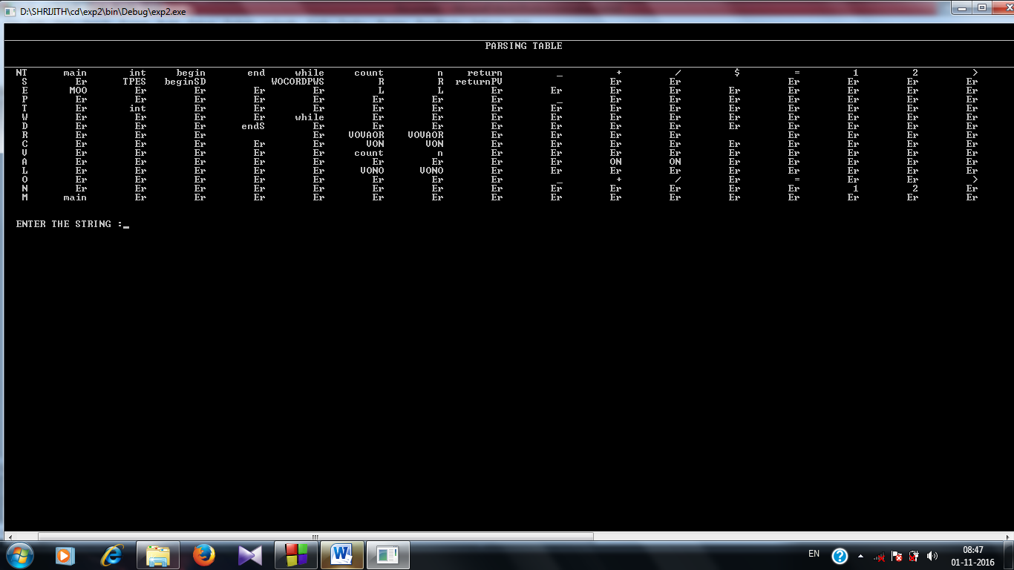end

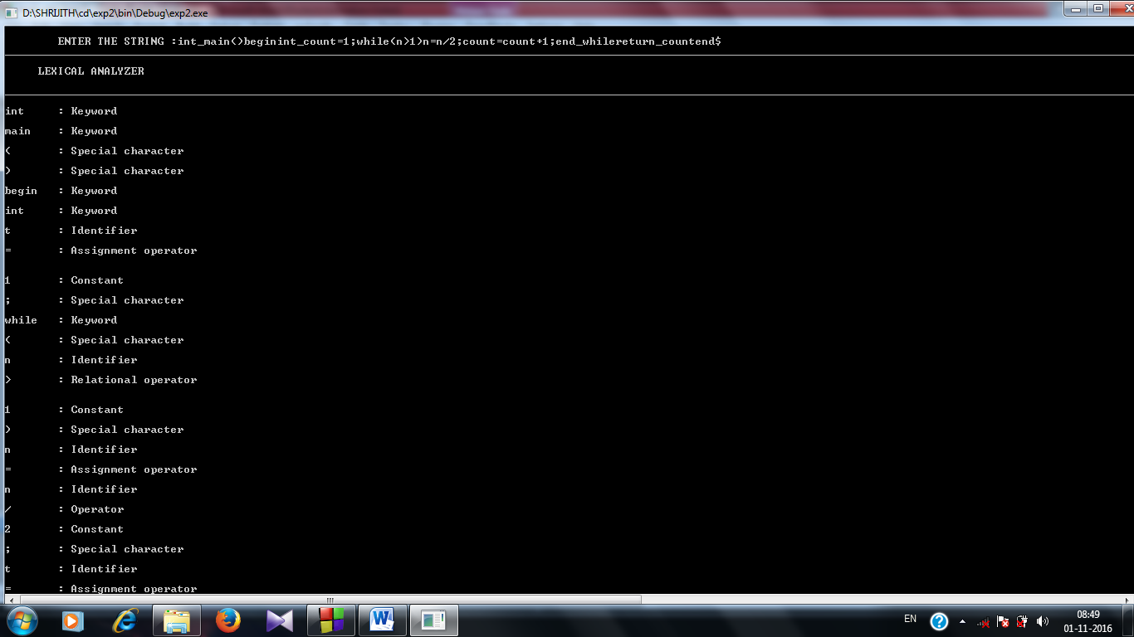**Lexical analysis:**

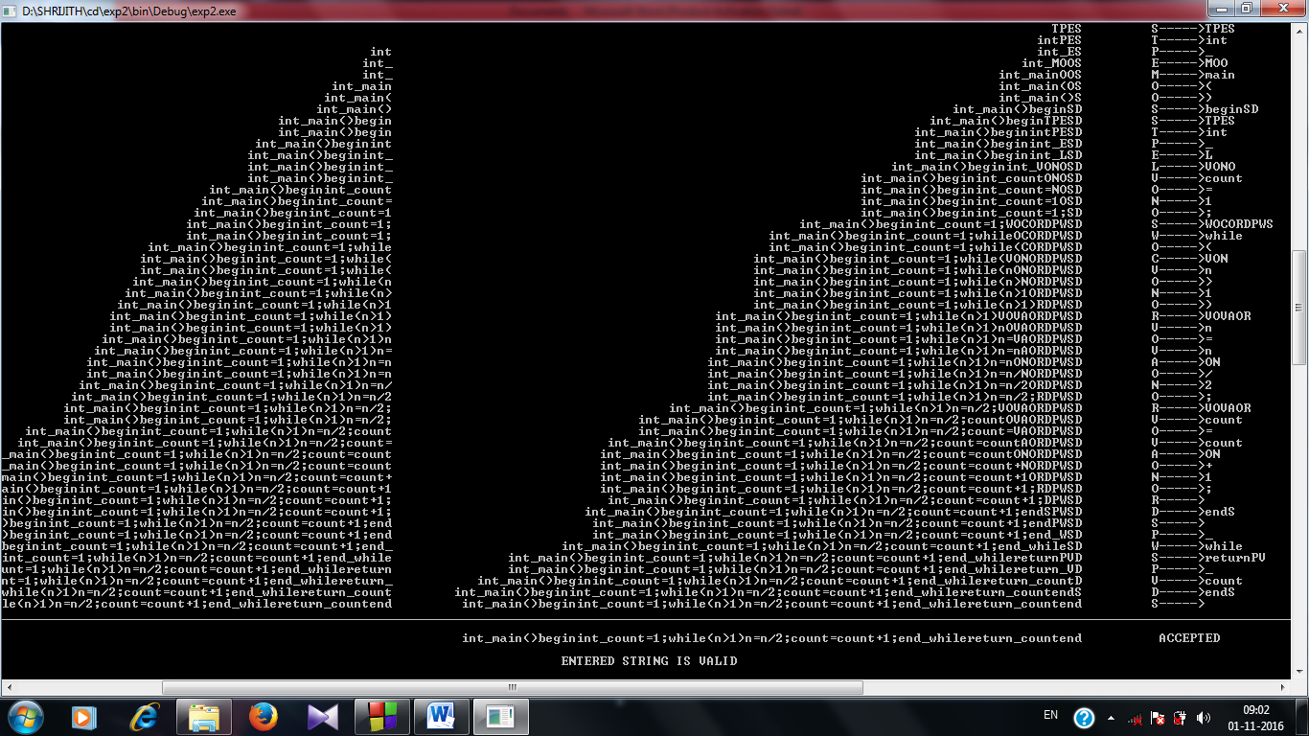

**Parsing Table:**

**CONCLUSION**

In lexical analysis when we give a program statement as input, the keywords ,identifiers ,operators and numbers are displayed. Each of these are the tokens of the statement.

In top down parser, on giving an input string, the string is parsed as per the grammar and parsing table given in the program. If the string was parsed completely then the leftmost derivation of the string is displayed in the output else a syntax error is displayed.

**BIBLIOGRAPHY**

* PRINCIPLES OF COMPLIER DESIGN-ALFRED AHO,JEFFERY D.ULMAN